PROJECT REPORT ON
_PYTHON_

REPORT SUBMITTED TO:
VISHWAKARMA INSTITUTE OF INFORMATION TECHNOLOGY, PUNE
FOR
THE PBL OF COMPUTER FUNDAMENTAL
IN
ENGINEERING AND APPLIED SCIENCE DEPARTMENT
BY

Class: fy Division: C Batch: C1

Name | Roll no | Prn no
Om bhoir | 311 | 22110163
Kushal jain | 312 | 22110179
Rushikesh sanap | 313 | 22110211
Sumant pakhare | 314 | 22110227
Prachi lakhe | 315 | 22110243

Batch Teacher: Kalpana kumbharkar

INDEX

Sr. No. | Contents | Page No.
1 | ABSTRACT
2 | INTRODUCTION AND THEORY
3 | EXPERIMENTAL DETAILS  Algorithm  Flowchart  Program
4 | RESULTS
5 | CONCLUSION
6 | REFERENCE

ABSTRACT
Flappy bird is one of the favorite game , which was used to play in an android version .Flappy Bird is an arcade-style game in which the player controls the bird Faby, which moves persistently to the right. The player is tasked with navigating Faby through pairs of pipes that have equally sized gaps placed at random heights. Faby automatically descends and only ascends when the player taps the keyspace. Each successful pass through a pair of pipes awards the player one point. Colliding with a pipe or the ground ends the gameplay.

Introduction and theory
So to make this game using python firstly it was needed to install pygame and many library in pygame using pip install.After that we
Set the height and width of screen to which the game will be played , now we have to define some images which will be used in our game like pipe as hurdles , bird image , also background , image of flappy bird . After the images were declared we created the main function , then welcome screen .The main function was made in which random pipe code was written , which lead us to play the game . after that gameover was defines in which few images were imported as we needed to have a image after the bird collides the pipe and game is over. Also two options were aligned on the gameover page , so that if user wanted to see the welcomescreen then he can go to the screen or otherwise he can directly play the game
Some imp points of the game :
- The player controls the bird by pressing space bar.
- Random height vertical pipes are generated from top and
bottom of the screen with little gap in between.
- The player needs to control the bird such that it won't collide
with the vertical pipes.
- The bird falls at a given acceleration if space bar is not
pressed.
- The score gets increased when the bird passes the pipes.
- If the bird collides with any of the pipes, then the game is
Over.
- If the game is over, pressing the "Enter" key will start a
new game.

algorithm
Step 1 : Start
Step 2 : Run the main Loop
Step 3 : Run the game
If loaded:
Draw Bird
Draw Background
Draw Pipes
Step 4 : While running:
If Collision Detected:
Go to Step 6
Else :
Go to Step 3
Step 5 : While paused:
Display Score
If resumed :
Go to step 3
Step 6 : EXIT

flowchart
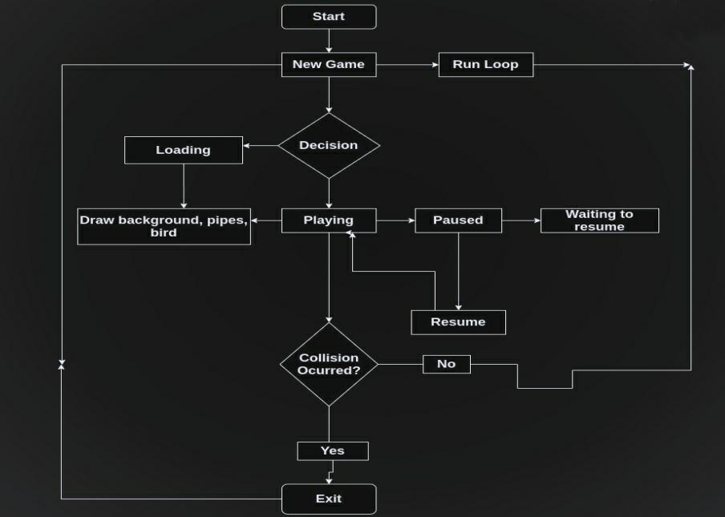

Program
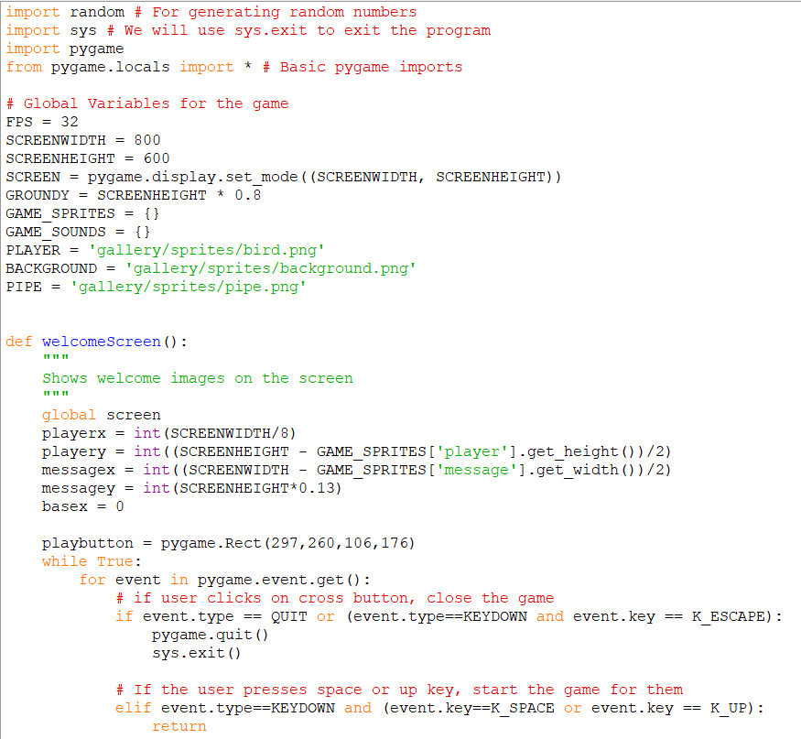

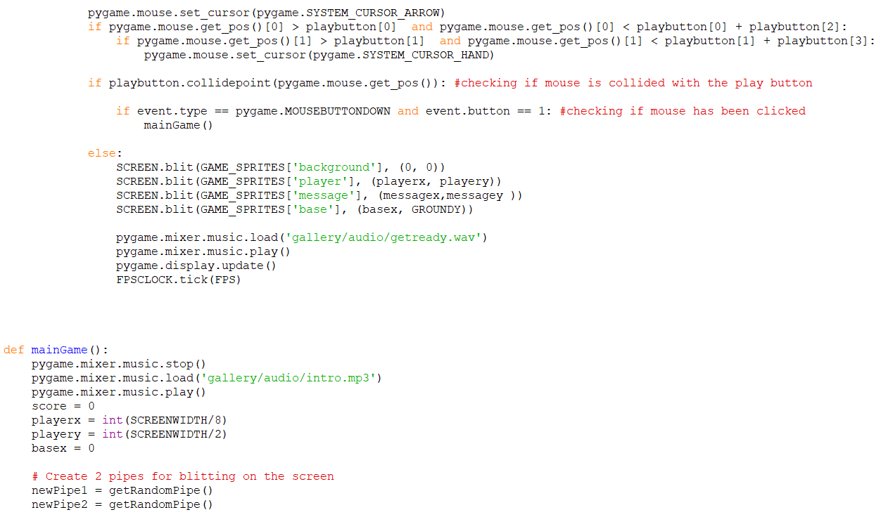
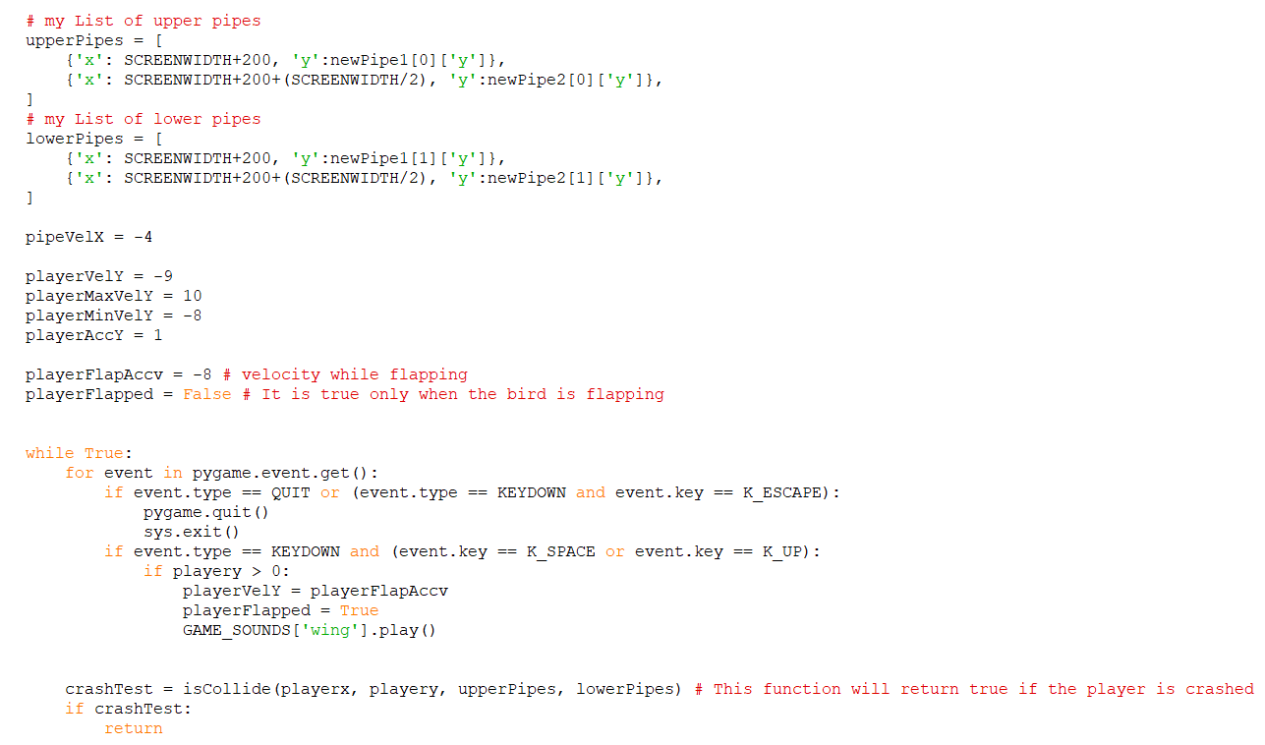
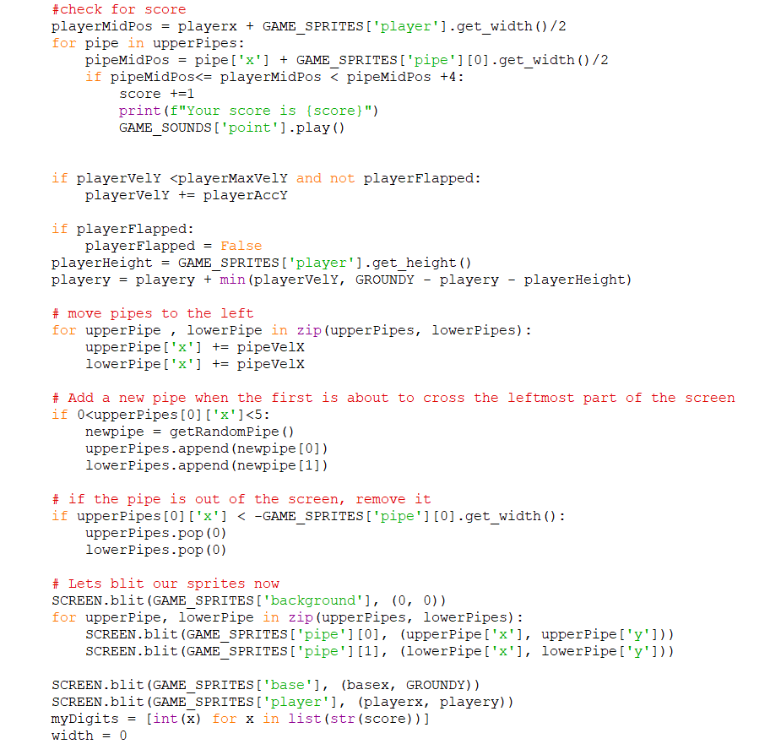
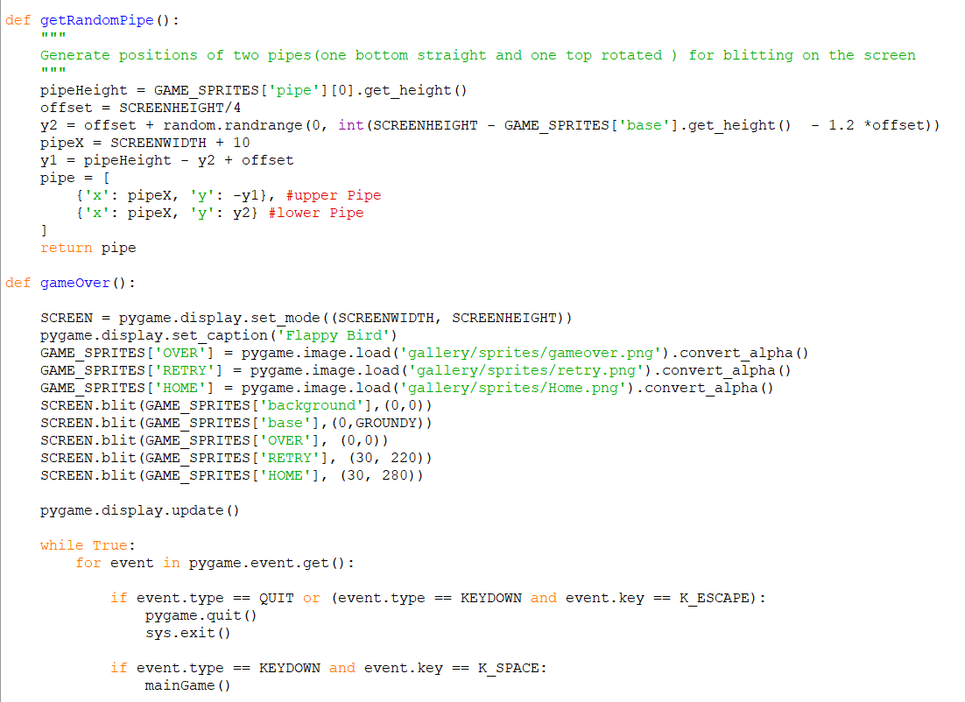
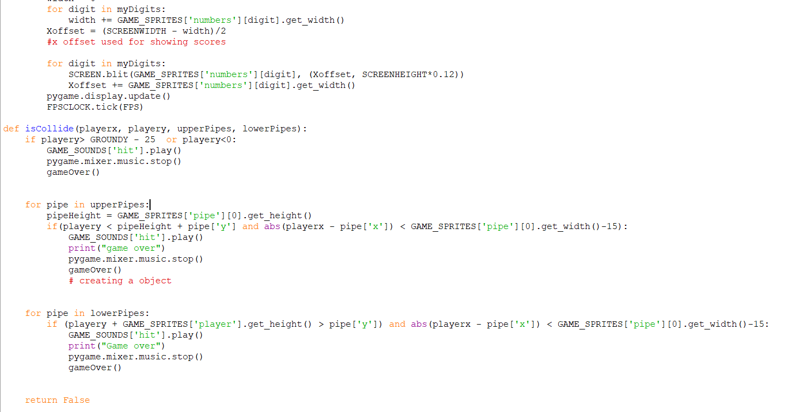
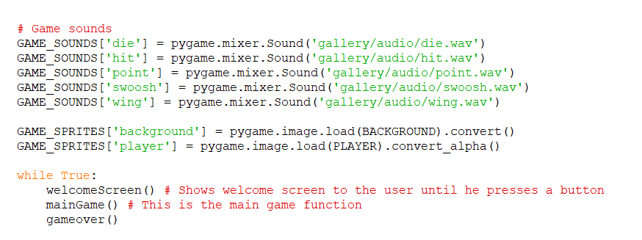
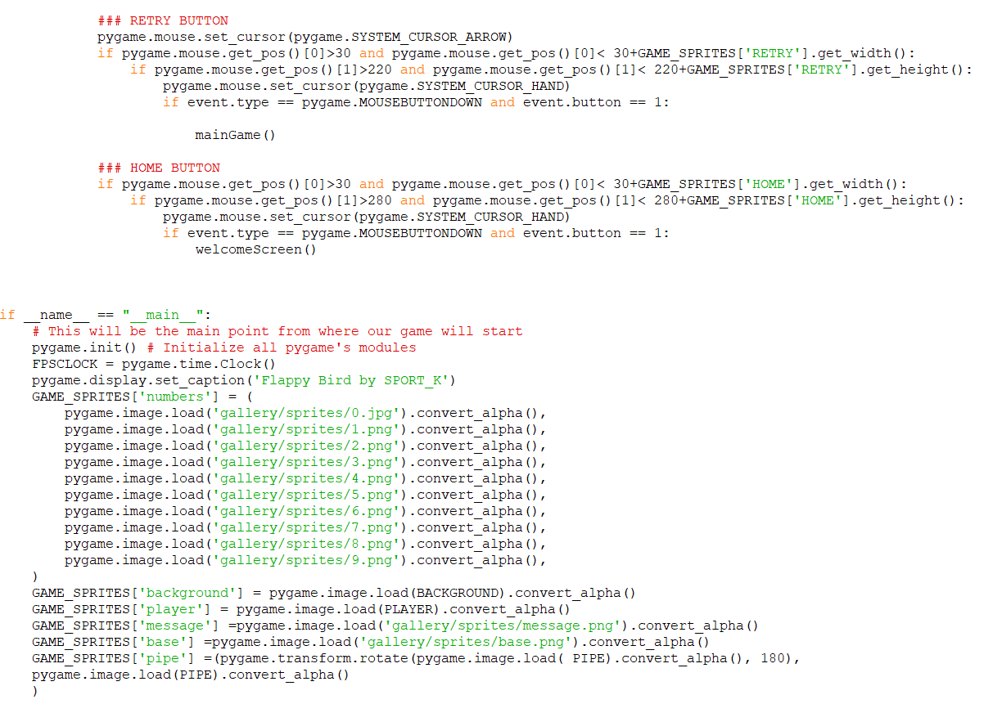

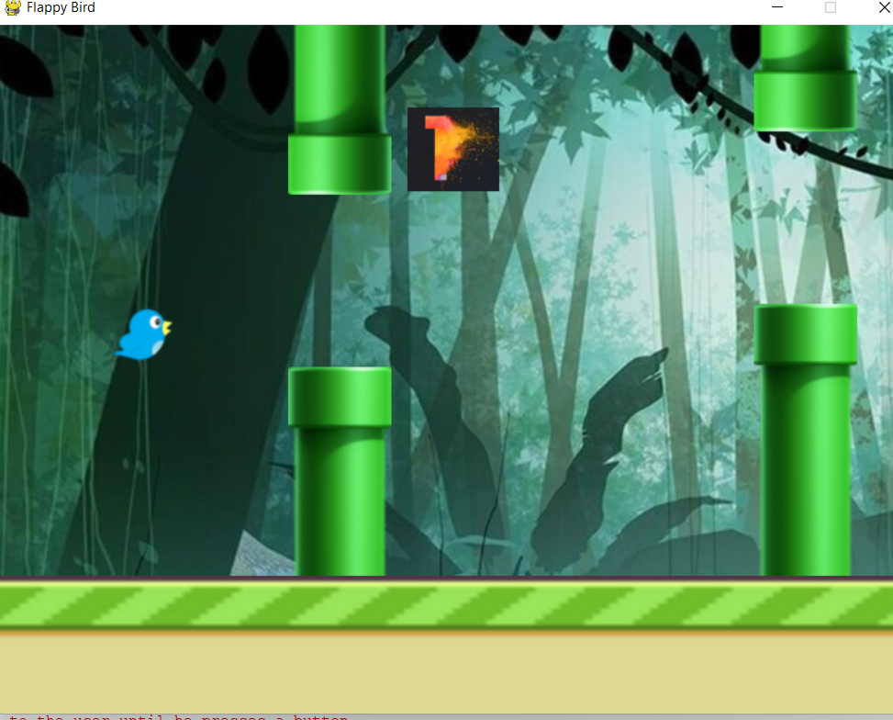
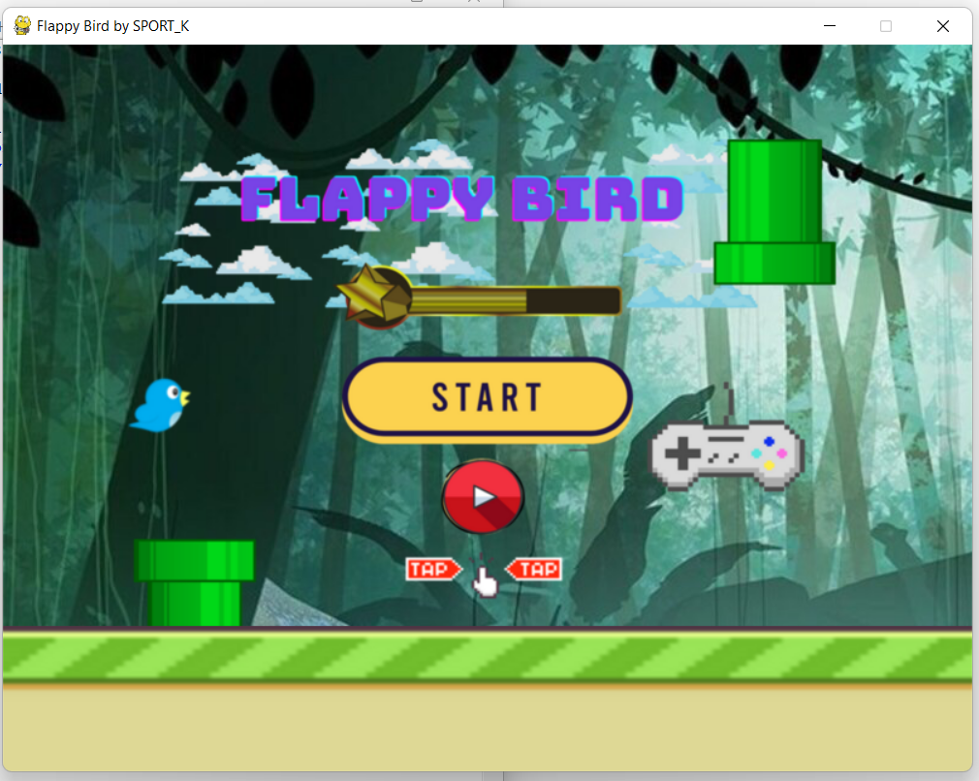
Output:
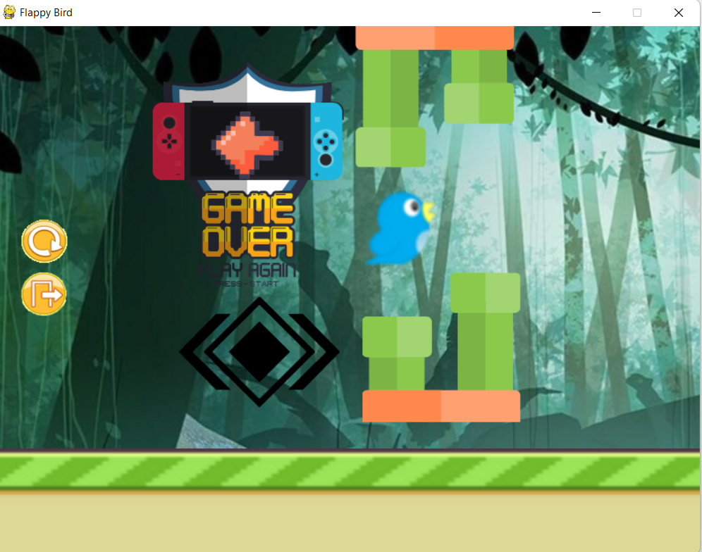
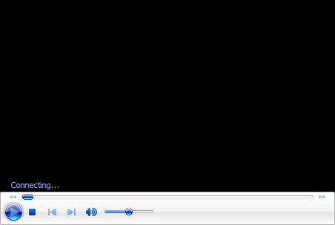

conclusion

From this we learnt how to put pictures in motion and create a game , how to import libraries and its application , how to put sound in game . also how to make a game using a simple and less code .

REFRENCES
1]Images= google
2]sound= youtube studio
3]library info = Welcome to Python.org
4]how to build welcomescreen = youtube

